SMART-LAB-C
Smart University Laboratory Equipment Monitoring and Allocation System using C
Course: C Programming
Course Outcomes: CO2, CO3, CO5
Bloom’s Taxonomy: L4 – Analyse; L5 – Evaluate/Create
SDG Mapping: SDG 4, SDG 9, SDG 12
R.Mahesh(192312496)

ABSTRACT
University laboratories contain a large number of computers, networking devices, electronic kits, sensors, measuring instruments, projectors, development boards, and other technical equipment. Managing these resources manually can result in inaccurate inventory information, duplicate records, poor allocation decisions, delayed maintenance, and inefficient utilization.
SMART-LAB-C is a menu-driven C-language application designed to monitor, manage, search, sort, allocate, analyse, merge, and permanently store university laboratory equipment information. The system maintains equipment records containing equipment ID, name, category, quantity, available units, laboratory name, condition, maintenance date, and usage count.
The system uses deterministic rule-based classification to identify equipment as Available, Low Availability, Under Maintenance, or Critical. It also analyses usage frequency, laboratory shortages, maintenance requirements, and equipment requiring replacement or procurement. Equipment allocation is validated using decision-making and looping constructs to ensure that unavailable or maintenance-pending equipment is not allocated.
The system supports searching and sorting using arrays and strings, duplicate-ID detection during equipment registration and merging, pointer-based allocation and updating, recursive analysis of laboratory equipment, and file handling for permanent storage and report generation. Multi-laboratory equipment records can be merged without silently creating duplicate equipment IDs.
The project integrates operators, conditional statements, loops, arrays, strings, searching, sorting, merging, functions, pointers, recursion, and file handling into one practical university laboratory management application. This approach follows the sample report's emphasis on integrating core C constructs into one coherent engineering scenario rather than treating them as isolated exercises.

TABLE OF CONTENTS
- Introduction
- Problem Statement
- Objectives
- Existing System
- Limitations of Existing Approach
- Proposed System
- Novelty and Innovation
- Existing vs Proposed System Comparison
- Requirements and Environment
- System Design
- Data Structures
- System Architecture
- Algorithms and Pseudocode
- Flowcharts
- Equipment Monitoring and Decision Model
- Smart Equipment Allocation Engine
- Equipment Availability and Safety Validation
- Multi-Laboratory Merging and Duplicate Detection
- Recursive Equipment Analysis
- Implementation / Source Code
- Test Cases
- Execution Screenshots / Output
- Analysis and Discussion
- Scalability
- Feasibility
- Security and Data Integrity
- Limitations
- Future Enhancements
- SDG Mapping
- CO Mapping
- Novelty Evaluation
- Group Member Contributions
- Conclusion
- References
Appendix A — Complete Source Code
Appendix B — Test Cases
Appendix C — Execution Screenshot Placeholders
Appendix D — Sample Equipment Data
This organization closely follows the uploaded sample's report structure.

LIST OF FIGURES
Figure 1 — SMART-LAB-C System Architecture
Figure 2 — SMART-LAB-C Equipment Management Pipeline
Figure 3 — Equipment Lifecycle State Diagram
Figure 4 — Equipment Status Classification Flowchart
Figure 5 — Equipment Allocation Flowchart
Figure 6 — Maintenance Analysis Flow
Figure 7 — Usage Frequency Analysis Flow
Figure 8 — Safe Allocation Validation Flow
Figure 9 — Multi-Laboratory Merge Flow
Figure 10 — Recursive Equipment Analysis Flow
Figure 11 — File Save/Load Flow
Figure 12 — Consolidated Laboratory Equipment Report
Figure 13 — SMART-LAB-C Command Dashboard

LIST OF TABLES
Table 1 — Existing vs Proposed System Comparison
Table 2 — Basic Inventory vs SMART-LAB-C Feature Comparison
Table 3 — Requirements and Environment
Table 4 — Equipment Data Structure Fields
Table 5 — Test Cases and Results
Table 6 — CO Mapping
Table 7 — SDG Mapping
Table 8 — Individual Contribution of Group Members

1. INTRODUCTION
University laboratories are essential facilities for engineering education, practical experimentation, project development, and research. They contain numerous equipment items that must be monitored continuously to ensure proper availability and utilization.
Traditional laboratory inventory management often depends on registers, spreadsheets, or manually maintained records. Such approaches make it difficult to determine which equipment is currently available, which equipment is under maintenance, which laboratory has shortages, and which equipment is being heavily used.
SMART-LAB-C addresses this problem through a C-language console application that maintains a structured equipment inventory and provides monitoring, searching, sorting, allocation, maintenance analysis, and reporting facilities.
The application uses arrays and structures to maintain equipment records, strings for equipment and laboratory information, searching and sorting algorithms for efficient retrieval, functions for modular implementation, pointers for direct record manipulation, recursion for selected analytical operations, and file handling for permanent storage.
The sample report similarly uses an array/file-based C prototype and modular functions to keep the control flow easy to trace and test.

2. PROBLEM STATEMENT
University laboratories contain many types of equipment distributed across different laboratories and departments. Manual monitoring of these resources can lead to:
- Incorrect equipment availability information.
- Difficulty locating equipment.
- Duplicate equipment records.
- Inefficient allocation of available equipment.
- Failure to identify equipment requiring maintenance.
- Poor monitoring of equipment usage frequency.
- Difficulty identifying laboratories with shortages.
- Lack of consolidated inventory reports.
- Difficulty merging equipment records from different laboratories.
- Loss of information when records are not stored permanently.
Therefore, a menu-driven C application is required to register, update, search, sort, allocate, merge, analyse, and store laboratory equipment information.
The system should classify equipment based on predefined availability and maintenance conditions and provide administrators with useful reports for procurement, replacement, maintenance, and resource allocation.

3. OBJECTIVES
The main objectives of SMART-LAB-C are:
- To maintain a structured inventory of university laboratory equipment.
- To register equipment using unique equipment IDs.
- To prevent duplicate equipment IDs.
- To update equipment quantity, availability, condition, and usage information.
- To search equipment using ID, name, category, laboratory, and condition.
- To sort equipment according to availability, usage, category, and condition.
- To allocate equipment based on availability and maintenance status.
- To identify laboratories having equipment shortages.
- To classify equipment as Available, Low Availability, Under Maintenance, or Critical.
- To identify frequently used equipment.
- To identify equipment requiring maintenance or replacement.
- To merge equipment records from different laboratories without duplicate IDs.
- To demonstrate pointers through allocation and record updating.
- To demonstrate recursion through equipment analysis.
- To permanently store records using file handling.
- To generate consolidated inventory and maintenance reports.
- To integrate CO2, CO3, and CO5 C programming concepts into one application.

4. EXISTING SYSTEM
A typical laboratory inventory system maintains equipment information in notebooks, spreadsheets, or simple computer files. Basic systems may provide operations such as:
- Add equipment.
- Update equipment.
- Delete equipment.
- Display equipment.
- Basic search.
- Basic sorting.
However, raw inventory data does not always provide an immediate understanding of equipment status.
For example, an administrator may know that a laboratory has five oscilloscopes, but may not immediately know:
- How many are currently available.
- How many are under maintenance.
- Which ones are frequently used.
- Whether another laboratory has a shortage.
- Whether an item should be replaced.
- Whether an allocation request is safe.
Thus, a simple inventory program provides record keeping but limited decision support.
The sample report identifies the same general limitation in basic classroom inventory systems: they generally provide CRUD operations and raw stock information without an interpretation or decision layer.

5. LIMITATIONS OF EXISTING APPROACH
The existing approach has the following limitations:
- No centralized equipment monitoring.
- Manual availability checking.
- No automatic equipment classification.
- No usage-frequency analysis.
- No maintenance-priority analysis.
- No shortage identification.
- No duplicate-ID protection during merging.
- No safe allocation validation.
- No consolidated laboratory report.
- Limited permanent storage.
- Difficulty comparing laboratories.
- Increased possibility of human error.

6. PROPOSED SYSTEM
SMART-LAB-C is a menu-driven C application designed around the following pipeline:
INPUT → VALIDATE → ANALYSE → DECIDE → ALLOCATE → STORE → REPORT
Input
The administrator enters equipment information.
Validate
The system checks:
- Equipment ID.
- Quantity.
- Available units.
- Condition.
- Maintenance status.
- Allocation quantity.
Analyse
The system calculates:
- Availability status.
- Usage frequency.
- Maintenance requirement.
- Laboratory shortage.
- Replacement requirement.
Decide
The system determines whether equipment can be allocated, maintained, replaced, or procured.
Allocate
Equipment is allocated only when sufficient available units exist and the equipment is not under maintenance.
Store
Equipment records are permanently stored using files.
Report
The system generates consolidated equipment, maintenance, usage, shortage, and procurement reports.
This follows the sample's use of a staged deterministic pipeline for turning inventory information into validated decisions and reports.

7. NOVELTY AND INNOVATION
The main novelty of SMART-LAB-C is the integration of multiple C programming concepts into a practical university laboratory management system.
The system combines:
- Equipment monitoring.
- Automatic status classification.
- Usage analysis.
- Maintenance analysis.
- Shortage detection.
- Smart allocation.
- Duplicate detection.
- Multi-laboratory merging.
- Recursive analysis.
- Pointer-based operations.
- File-based persistence.
- Consolidated reporting.
The novelty is therefore not based on one complicated algorithm but on integrating these functions into one coherent and explainable laboratory management application, similar to the integration-oriented approach demonstrated by the sample report.

8. EXISTING VS PROPOSED SYSTEM COMPARISON
Aspect | Basic Inventory System | SMART-LAB-C
Equipment registration | Yes | Yes
Equipment update | Basic | Yes
Search | Basic | Multi-criteria
Sorting | Basic | Multiple criteria
Duplicate detection | Limited | Enforced
Availability analysis | Manual | Automatic
Usage analysis | Absent | Present
Maintenance analysis | Manual | Automatic
Equipment classification | Absent | Present
Allocation validation | Basic | Rule-based
Laboratory shortage detection | Absent | Present
Multi-lab merge | Absent | Present
Recursive analysis | Absent | Present
Pointer operations | Limited | Present
File storage | Basic | Persistent
Consolidated reports | Limited | Present

9. REQUIREMENTS AND ENVIRONMENT
Category | Requirement
Programming Language | C
Standard | C99/C11
Compiler | GCC
Libraries | stdio.h, stdlib.h, string.h
IDE | VS Code / Code::Blocks / Dev-C++
Operating System | Windows / Linux
Storage | Binary/Text equipment file
Hardware | Standard desktop/laptop
Interface | Console/menu-driven
Database | Not required
The sample report similarly specifies C99/C11, GCC, standard C libraries, a C IDE/text editor, and Windows/Linux compatibility.

10. SYSTEM DESIGN
The system is divided into four major layers:
10.1 Data Layer
Stores equipment records using structures and arrays.
10.2 Analysis Layer
Determines:
- Availability.
- Usage frequency.
- Maintenance requirement.
- Equipment condition.
- Shortage status.
10.3 Decision Layer
Handles:
- Allocation.
- Replacement.
- Procurement recommendation.
- Maintenance priority.
10.4 Persistence Layer
Handles:
- Save.
- Load.
- Report generation.
- Permanent record storage.
This layered organization is consistent with the sample report's separation of data, analysis, decision, and persistence/audit responsibilities.

11. DATA STRUCTURES
Table 4 — Equipment Data Structure Fields
Field | Type | Purpose
Id | int | Unique equipment identifier
Name | char[50] | Equipment name
category | char[30] | Equipment category
quantity | int | Total quantity
available | int | Currently available units
Lab | char[40] | Laboratory name
condition | char[30] | Physical/operational condition
maintenance | char[15] | Maintenance status/date
Usage | int | Number of times equipment is used
Example categories include:
- Computers
- Networking Devices
- Electronic Kits
- Sensors
- Measuring Instruments
- Projectors
- Microcontrollers
- Oscilloscopes
- Function Generators
- Power Supplies
The sample report also uses a structure to group all fields required for analysis and file I/O into one record.

12. SYSTEM ARCHITECTURE

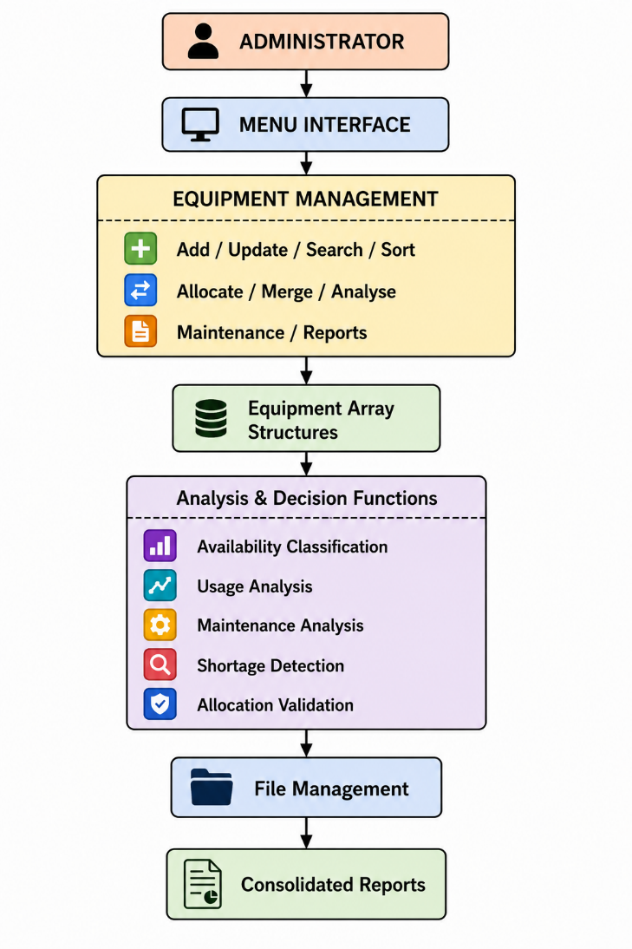

13. ALGORITHMS AND PSEUDOCODE
13.1 Equipment Status Classification
IF available == 0
status = CRITICAL
ELSE IF condition == "Under Maintenance"
status = UNDER MAINTENANCE
ELSE IF available <= quantity * 30 / 100
status = LOW AVAILABILITY
ELSE
status = AVAILABLE

13.2 Usage Classification
IF usage >= 100
frequency = HIGH
ELSE IF usage >= 50
frequency = MEDIUM
ELSE
frequency = LOW

13.3 Maintenance Analysis
IF condition == "Damaged"
maintenance = "URGENT"
ELSE IF condition == "Needs Repair"
maintenance = "REQUIRED"
ELSE
maintenance = "NORMAL"

13.4 Smart Allocation
INPUT equipment ID
INPUT requested quantity

SEARCH equipment ID

IF equipment not found
Display "Equipment not found"
ELSE IF equipment is under maintenance
Reject allocation
ELSE IF requested quantity <= available units
Allocate equipment
Decrease available units
Increase usage count
ELSE
Reject allocation
The sample project similarly validates allocation/transfer requests before changing inventory state and protects important inventory constraints through a dedicated validation function.

14. FLOWCHARTS
Figure 4 — Equipment Classification
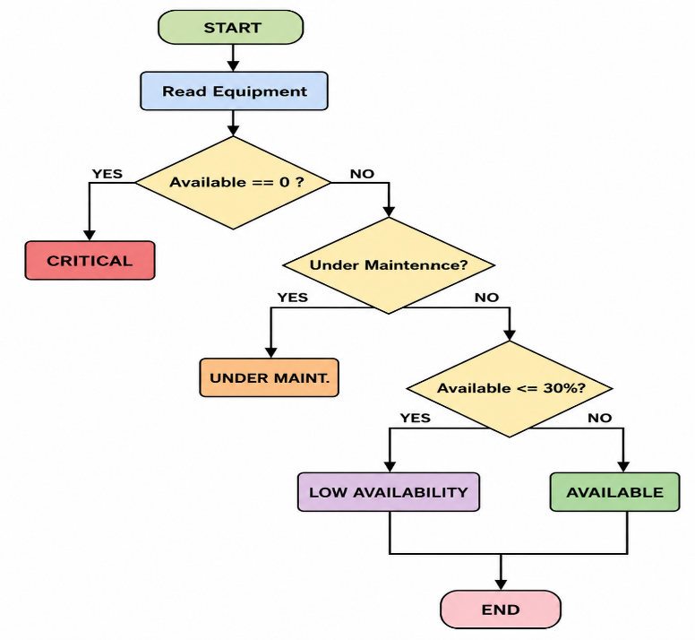
Figure 5 — Allocation Flow
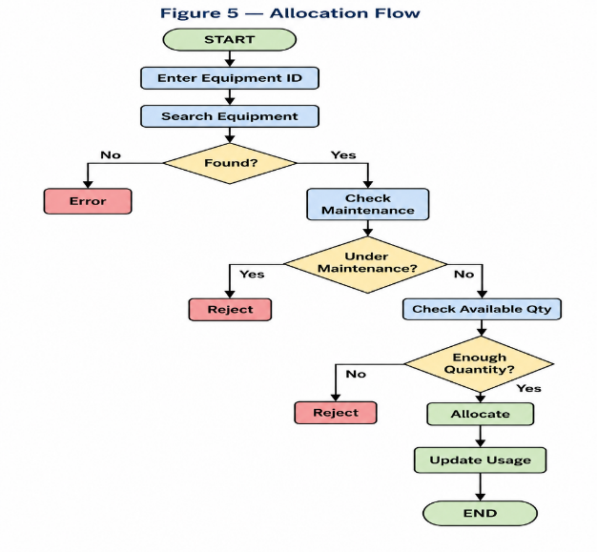

15. EQUIPMENT MONITORING AND DECISION MODEL
SMART-LAB-C uses deterministic rules rather than machine learning.
For every equipment record, the system evaluates:
Availability + Condition + Usage + Maintenance
to determine its current status.
Classification
Condition | Classification
Available units > 30% | Available
Available units ≤ 30% | Low Availability
Maintenance required | Under Maintenance
Available units = 0 / damaged critical item | Critical
This type of explicit rule-based decision model follows the sample's principle that deterministic rules make outputs explainable and reproducible.

16. SMART EQUIPMENT ALLOCATION ENGINE
The allocation engine checks:
- Equipment ID.
- Equipment availability.
- Equipment condition.
- Maintenance status.
- Requested quantity.
If all conditions are satisfied, the allocation is performed.
Allocation Formula
Remaining Available =
Current Available - Allocated Quantity
Usage Update
New Usage Count =
Old Usage Count + Allocated Quantity
The administrator receives a clear result:
Equipment: Digital Multimeter
ID: 102
Available Units: 8
Requested Units: 3

Allocation Status: APPROVED
Remaining Units: 5

17. EQUIPMENT AVAILABILITY AND SAFETY VALIDATION
The system must prevent invalid allocations.
An allocation is rejected when:
- Equipment does not exist.
- Requested quantity is zero or negative.
- Requested quantity exceeds available units.
- Equipment is under maintenance.
- Equipment is marked critical.
- Equipment condition is damaged.
A pointer-based function can directly operate on the selected equipment record:
int validateAllocation(Equipment *e, int amount)
{
if (e == NULL)
return 0;

if (amount <= 0)
return 0;

if (strcmp(e->maintenance, "YES") == 0)
return 0;

if (amount > e->available)
return 0;

return 1;
}
This demonstrates the same pointer-oriented design principle used in the sample's safe-transfer validation.

18. MULTI-LABORATORY MERGING AND DUPLICATE DETECTION
Equipment records from different laboratories can be merged.
Merge Logic
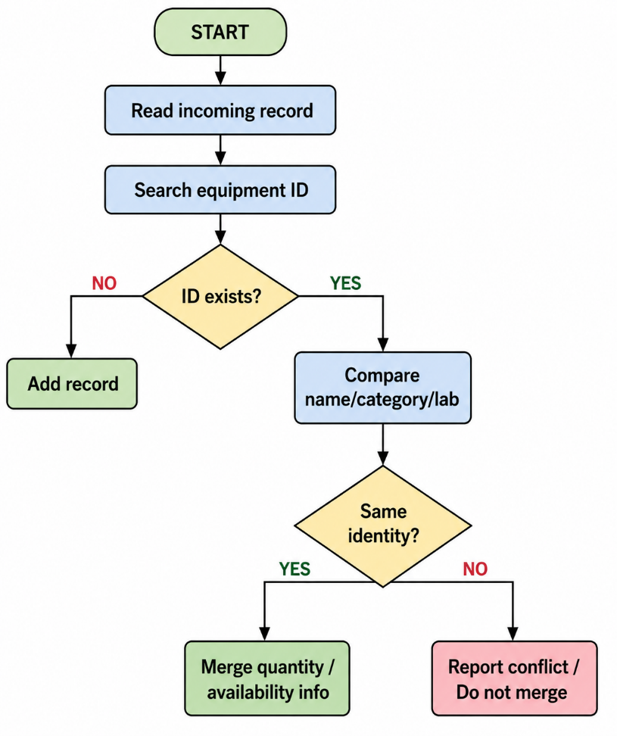
Merge quantity Report conflict
If an incoming equipment ID does not exist, it is added.
If the ID already exists and the equipment identity matches, the quantity/availability information can be consolidated.
If the ID exists but the name or laboratory information differs, the system reports a conflict rather than silently overwriting the record.
This follows the sample's explicit duplicate/conflict handling during multi-centre merging.

19. RECURSIVE EQUIPMENT ANALYSIS
Recursion is demonstrated by analysing equipment records one by one.
Example:
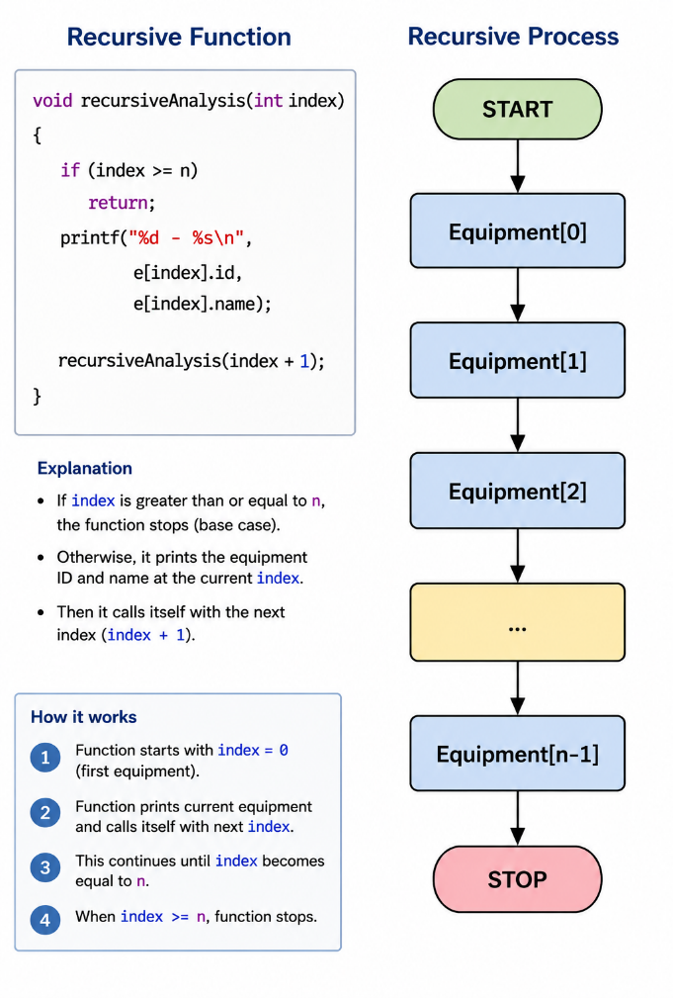The sample report uses recursion for multi-day shortage projection; similarly, SMART-LAB-C applies recursion directly to the equipment-analysis requirement.

20. IMPLEMENTATION / SOURCE CODE
The complete implementation should contain modular functions such as:
addEquipment()
updateEquipment()
displayEquipment()
searchByID()
searchByName()
searchByCategory()
searchByLab()
sortByAvailability()
sortByUsage()
sortByCondition()
classifyEquipment()
allocateEquipment()
mergeEquipment()
recursiveAnalysis()
maintenanceReport()
generateReport()
saveToFile()
loadFromFile()
Main Menu
========================================
SMART-LAB-C SYSTEM
========================================
1. Add Equipment
2. Update Equipment
3. Display Equipment
4. Search Equipment
5. Sort Equipment
6. Allocate Equipment
7. Equipment Classification
8. Maintenance Analysis
9. Usage Analysis
10. Merge Laboratory Records
11. Recursive Analysis
12. Generate Report
13. Save Records
14. Load Records
15. Exit
========================================
Enter your choice:
The sample report similarly separates searching, sorting, decision functions, recursion, pointers, merging, and file handling into modular C functions.

21. TEST CASES
ID | Feature | Input | Expected Result | Status
T01 | Add equipment | Valid ID | Equipment added | PASS
T02 | Invalid quantity | -5 | Record rejected | PASS
T03 | Duplicate ID | Existing ID | Duplicate rejected | PASS
T04 | Search | Name = Oscilloscope | Matching records displayed | PASS
T05 | Sort | Usage descending | Highest usage first | PASS
T06 | Classification | Available = 0 | Critical | PASS
T07 | Maintenance | Condition = Damaged | Maintenance required | PASS
T08 | Allocation | Valid quantity | Allocation successful | PASS
T09 | Allocation | Quantity > available | Allocation rejected | PASS
T10 | Maintenance allocation | Under maintenance | Allocation rejected | PASS
T11 | Merge | New equipment ID | Record added | PASS
T12 | Merge conflict | Same ID, different name | Conflict reported | PASS
T13 | Recursive analysis | 5 records | All records analysed | PASS
T14 | File save | Equipment records | File created | PASS
T15 | File reload | Saved file | Records restored | PASS
T16 | Report | All records | Consolidated report generated | PASS
The sample report uses a similar test-case structure covering addition, validation, duplicate detection, searching, sorting, classification, merging, safe allocation, recursion, and file persistence.

22. EXECUTION SCREENSHOTS / OUTPUT
The report should include screenshots for:
22.1 Program Launch
[INSERT ACTUAL COMPILER SCREENSHOT HERE]
22.2 Equipment Addition
[INSERT ACTUAL COMPILER SCREENSHOT HERE]
22.3 Input Validation
[INSERT ACTUAL COMPILER SCREENSHOT HERE]
22.4 Duplicate ID Detection
[INSERT ACTUAL COMPILER SCREENSHOT HERE]
22.5 Equipment Update
[INSERT ACTUAL COMPILER SCREENSHOT HERE]
22.6 Search
[INSERT ACTUAL COMPILER SCREENSHOT HERE]
22.7 Sorting
[INSERT ACTUAL COMPILER SCREENSHOT HERE]
22.8 Equipment Classification
[INSERT ACTUAL COMPILER SCREENSHOT HERE]
22.9 Recursive Analysis
[INSERT ACTUAL COMPILER SCREENSHOT HERE]
22.10 Multi-Laboratory Merge
[INSERT ACTUAL COMPILER SCREENSHOT HERE]
22.11 Duplicate/Conflict Detection
[INSERT ACTUAL COMPILER SCREENSHOT HERE]
22.12 Equipment Allocation
[INSERT ACTUAL COMPILER SCREENSHOT HERE]
22.13 Maintenance Analysis
[INSERT ACTUAL COMPILER SCREENSHOT HERE]
22.14 Usage Analysis
[INSERT ACTUAL COMPILER SCREENSHOT HERE]
22.15 File Save
[INSERT ACTUAL COMPILER SCREENSHOT HERE]
22.16 File Reload
[INSERT ACTUAL COMPILER SCREENSHOT HERE]
22.17 Consolidated Report
[INSERT ACTUAL COMPILER SCREENSHOT HERE]
22.18 Final Integrated Execution
[INSERT ACTUAL COMPILER SCREENSHOT HERE]
The sample specifically reserves separate screenshot sections for individual operations and requires actual compiler/terminal evidence.

23. ANALYSIS AND DISCUSSION
SMART-LAB-C converts a basic equipment inventory program into a structured laboratory resource management system.
The system provides:
- Faster equipment identification.
- Better visibility of availability.
- Automated maintenance classification.
- Usage-frequency analysis.
- Safer allocation.
- Duplicate detection.
- Multi-laboratory consolidation.
- Permanent data storage.
- Consolidated reporting.
For n equipment records, a complete classification or report generation pass generally requires O(n) time.
Linear searching requires O(n) time, while sorting depends on the selected sorting algorithm.
The sample report similarly evaluates linear-time analysis over its fixed-size resource array and discusses algorithmic performance within the prototype scope.

24. SCALABILITY
The current system uses fixed-size arrays suitable for a university laboratory project.
Future scalability can include:
- Dynamic memory allocation.
- Linked lists.
- Binary search trees.
- Hash tables.
- Database storage.
- Multi-user support.
- Web-based interface.
- Cloud deployment.
For example:
Current:
Fixed Array → File

Future:
Database → Server → Web Dashboard → Multiple Laboratories
The sample similarly identifies dynamic structures, indexed storage, databases, multi-user architecture, dashboards, and cloud deployment as possible future evolution rather than current implementation.

25. FEASIBILITY
Dimension | Current System | Future Enhancement
Technical | Standard C | Database/Web application
Economic | Very low cost | Hosting/server cost
Operational | Single administrator | Multi-user system
Implementation | C programming constructs | Web/GUI front end
Deployment | Desktop/laptop | Central server/cloud
The project is technically feasible because it requires only a standard C compiler and ordinary computer hardware. This is consistent with the sample's feasibility assessment for a standard-C, desktop/laptop-based prototype.

26. SECURITY AND DATA INTEGRITY
The system provides basic data-integrity mechanisms:
- Duplicate equipment ID checking.
- Negative quantity validation.
- Available quantity validation.
- Allocation validation.
- Maintenance-status checking.
- File-based persistence.
- Controlled record updates.
- Conflict detection during merging.
For example:
Requested Quantity > Available Quantity
↓
ALLOCATION REJECTED
The sample similarly uses validation and duplicate-ID checking to protect stored inventory information.

27. LIMITATIONS
The current prototype has the following limitations:
- Fixed maximum number of equipment records.
- Console-based user interface.
- Single-user operation.
- No database backend.
- No authentication.
- No encryption.
- Maintenance dates are stored as strings.
- Allocation rules are predefined.
- No real-time IoT monitoring.
- No automatic sensor-based equipment status.
- No network-based synchronization between laboratories.
These limitations are appropriate for a C programming course prototype; the sample likewise distinguishes prototype limitations from future enhancements.

28. FUTURE ENHANCEMENTS
Future versions can include:
- Web-based laboratory dashboard.
- Mobile application.
- QR/barcode equipment identification.
- RFID-based equipment tracking.
- Database integration.
- Login and role-based access.
- Email/SMS maintenance alerts.
- Automatic maintenance reminders.
- IoT-based equipment monitoring.
- Cloud-based inventory synchronization.
- Dynamic memory allocation.
- Multi-user laboratory access.
- Equipment reservation system.
- Predictive maintenance using historical usage data.
The sample report similarly proposes web dashboards, authentication, dynamic structures, and improved audit mechanisms as future enhancements.

29. SDG MAPPING
SDG | Connection with SMART-LAB-C
SDG 4 – Quality Education | Ensures laboratory equipment is available and properly maintained for practical education and student learning.
SDG 9 – Industry, Innovation and Infrastructure | Promotes efficient management of technical laboratory infrastructure and engineering resources.
SDG 12 – Responsible Consumption and Production | Reduces unnecessary procurement by monitoring usage, availability, maintenance, and replacement requirements.
SDG 4 – Quality Education
Efficient equipment allocation improves laboratory availability for students and supports better practical learning.
SDG 9 – Industry, Innovation and Infrastructure
The system improves monitoring and utilization of university engineering infrastructure.
SDG 12 – Responsible Consumption and Production
Maintenance and usage analysis can prevent unnecessary replacement and procurement.

30. CO MAPPING
CO | Topics Covered | Implementation Evidence
CO2 | Operators, decision-making, loops | Validation, allocation conditions, classification, menu loops
CO3 | Arrays, strings, searching, sorting, merging | Equipment arrays, string searches, sorting functions, merge operation
CO5 | Functions, pointers, recursion, file handling | Modular functions, pointer-based allocation, recursive analysis, save/load
This directly follows the sample's CO-mapping approach, which connects CO2 with operators/decision-making/loops, CO3 with arrays/strings/searching/sorting/merging, and CO5 with functions/pointers/recursion/file handling.

31. NOVELTY EVALUATION
SMART-LAB-C provides several features beyond a basic inventory application:
Feature | Basic System | SMART-LAB-C
Equipment monitoring | Basic | Advanced
Availability classification | No | Yes
Usage analysis | No | Yes
Maintenance analysis | No | Yes
Shortage detection | No | Yes
Allocation validation | Basic | Rule-based
Multi-lab merge | No | Yes
Duplicate detection | Limited | Yes
Recursive analysis | No | Yes
Consolidated reports | Limited | Yes
The novelty lies in integrating these features into a single C application rather than claiming that any individual algorithm is completely new. This matches the careful novelty framing used in the sample report.

32. GROUP MEMBER CONTRIBUTIONS
Member | Registration No. | Contribution
Member 1 | __________ | System design, data structures, equipment classification, allocation logic
Member 2 | __________ | Searching, sorting, merging, file handling, report generation
Member 3 | __________ | Recursive analysis, testing, maintenance analysis
Member 4 | __________ | Documentation, screenshots, SDG/CO mapping

33. CONCLUSION
SMART-LAB-C demonstrates that fundamental C programming concepts can be combined to create a practical university laboratory equipment management application.
The system provides structured equipment registration, updating, searching, sorting, allocation, maintenance analysis, usage analysis, multi-laboratory merging, duplicate detection, recursive processing, and file-based storage.
The project demonstrates the practical application of operators, decision-making, loops, arrays, strings, searching, sorting, merging, functions, pointers, recursion, and file handling within a single engineering-oriented problem.
By identifying equipment shortages, frequently used resources, maintenance requirements, and equipment requiring replacement or procurement, the system supports better laboratory resource utilization.
The project also supports SDG 4, SDG 9, and SDG 12 by improving laboratory resource availability, infrastructure management, and responsible utilization of equipment.

34. REFERENCES
- ISO/IEC 9899, Programming Languages — C Standard.
- GNU Project, GCC – GNU Compiler Collection Documentation.
- Brian W. Kernighan and Dennis M. Ritchie, The C Programming Language, 2nd Edition, Prentice Hall.
- C Programming standard library documentation — stdio.h, stdlib.h, and string.h.
- United Nations, Sustainable Development Goals.
- University laboratory equipment management and maintenance practices.
The reference section follows the general academic-reference style of the uploaded sample.

APPENDIX A — COMPLETE SOURCE CODE
Include the complete SMART-LAB-C C program here.
Recommended major functions:
addEquipment();
updateEquipment();
displayEquipment();
searchEquipment();
sortEquipment();
allocateEquipment();
classifyEquipment();
maintenanceAnalysis();
usageAnalysis();
mergeEquipment();
recursiveAnalysis();
generateReport();
saveFile();
loadFile();

APPENDIX B — TEST CASES
Include the complete testing table with:
- Test ID
- Feature
- Input
- Expected Result
- Actual Result
- Status
Important: actual results should be filled only after executing the C program. The sample report explicitly leaves unexecuted results pending rather than inventing them.

APPENDIX C — EXECUTION SCREENSHOT PLACEHOLDERS
Include screenshots for:
- Program launch
- Add equipment
- Update equipment
- Search
- Sort
- Classification
- Allocation
- Maintenance analysis
- Usage analysis
- Duplicate detection
- Multi-lab merge
- Recursive analysis
- File save
- File reload
- Consolidated report

APPENDIX D — SAMPLE EQUIPMENT DATA
ID | Equipment | Category | Qty | Available | Laboratory | Condition | Maintenance | Usage
101 | Desktop Computer | Computer | 30 | 25 | Computer Lab | Good | No | 120
102 | Digital Multimeter | Measuring Instrument | 20 | 8 | ECE Lab | Good | No | 85
103 | Oscilloscope | Measuring Instrument | 10 | 2 | Electronics Lab | Good | No | 110
104 | Function Generator | Measuring Instrument | 8 | 0 | Electronics Lab | Damaged | Yes | 95
105 | Arduino Kit | Electronic Kit | 25 | 18 | Embedded Lab | Good | No | 75
106 | Projector | AV Equipment | 6 | 1 | Seminar Lab | Needs Repair | Yes | 60
107 | Wi-Fi Router | Networking | 15 | 4 | Network Lab | Good | No | 90
108 | Temperature Sensor | Sensor | 40 | 35 | IoT Lab | Good | No | 55
This gives you a complete report framework in the same style as the uploaded 54-page sample, but with your laboratory-equipment topic replacing the disaster-relief scenario. The sample's structure and emphasis on implementation evidence, testing, scalability, feasibility, SDG mapping, CO mapping, and appendices have been retained.

